Payment APIs

💳 What Are Payment APIs?
# Source: AI Source: Provided by: [Data Path: Persons Table -> ID Column: 1, Name_En Column: Motasem Essam] -> From: [Chatgpt (GPT‑5 Mini)] on [1/19/2026]
Payment APIs are web service interfaces that allow websites or apps to send, receive, and manage online payments securely. They handle complex tasks like processing credit cards, digital wallets, subscriptions, refunds, invoices, and more — so you don’t have to build a payment system from scratch.

✅ What Payment APIs Can Do
# Source: AI Source: Provided by: [Data Path: Persons Table -> ID Column: 1, Name_En Column: Motasem Essam] -> From: [Chatgpt (GPT‑5 Mini)] on [1/19/2026]
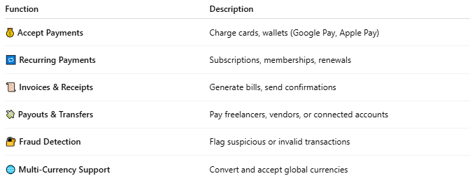

Function | Description
💰 Accept Payments | Charge cards, wallets (Google Pay, Apple Pay)
🔁 Recurring Payments | Subscriptions, memberships, renewals
📜 Invoices & Receipts | Generate bills, send confirmations
💸 Payouts & Transfers | Pay freelancers, vendors, or connected accounts
🔐 Fraud Detection | Flag suspicious or invalid transactions
🌐 Multi-Currency Support | Convert and accept global currencies

🧩 Popular Payment APIs
# Source: AI Source: Provided by: [Data Path: Persons Table -> ID Column: 1, Name_En Column: Motasem Essam] -> From: [Chatgpt (GPT‑5 Mini)] on [1/19/2026]
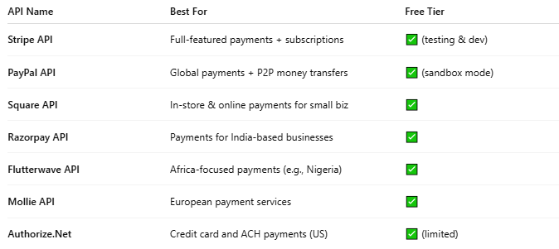

API Name | Best For | Free Tier
Stripe API | Full-featured payments + subscriptions | ✅ (testing & dev)
PayPal API | Global payments + P2P money transfers | ✅ (sandbox mode)
Square API | In-store & online payments for small biz | ✅
Razorpay API | Payments for India-based businesses | ✅
Flutterwave API | Africa-focused payments (e.g., Nigeria) | ✅
Mollie API | European payment services | ✅
Authorize.Net | Credit card and ACH payments (US) | ✅ (limited)

📤 Example: Stripe API (Charge a Card)
# Source: AI Source: Provided by: [Data Path: Persons Table -> ID Column: 1, Name_En Column: Motasem Essam] -> From: [Chatgpt (GPT‑5 Mini)] on [1/19/2026]
Request (using Stripe SDK):
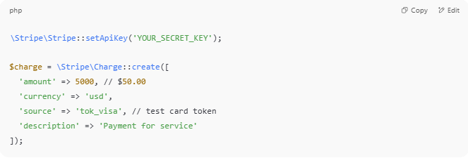
\Stripe\Stripe::setApiKey('YOUR_SECRET_KEY');

$charge = \Stripe\Charge::create([
'amount' => 5000, // $50.00
'currency' => 'usd',
'source' => 'tok_visa', // test card token
'description' => 'Payment for service'
]);

Response:
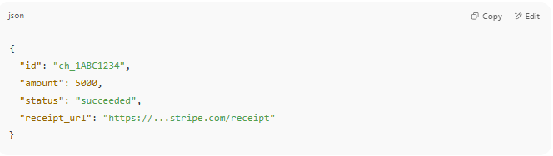
{
"id": "ch_1ABC1234",
"amount": 5000,
"status": "succeeded",
"receipt_url": "https://...stripe.com/receipt"
}

🛠️ Payment Methods Supported
# Source: AI Source: Provided by: [Data Path: Persons Table -> ID Column: 1, Name_En Column: Motasem Essam] -> From: [Chatgpt (GPT‑5 Mini)] on [1/19/2026]
- 💳 Credit/Debit Cards (Visa, MasterCard, etc.)
- 🧾 Bank Transfers (ACH, SEPA)
- 👜 Digital Wallets (Apple Pay, Google Pay, PayPal)
- 💱 Crypto (Bitcoin, Ethereum) – depends on the provider
- 📲 Mobile Money (M-Pesa, etc.)

🔐 Security Standards Used
# Source: AI Source: Provided by: [Data Path: Persons Table -> ID Column: 1, Name_En Column: Motasem Essam] -> From: [Chatgpt (GPT‑5 Mini)] on [1/19/2026]
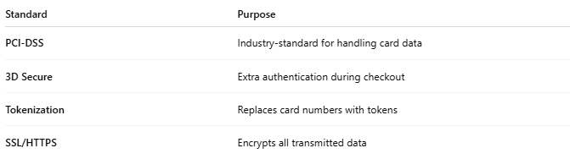

Standard | Purpose
PCI-DSS | Industry-standard for handling card data
3D Secure | Extra authentication during checkout
Tokenization | Replaces card numbers with tokens
SSL/HTTPS | Encrypts all transmitted data

🔁 Example Use Cases
# Source: AI Source: Provided by: [Data Path: Persons Table -> ID Column: 1, Name_En Column: Motasem Essam] -> From: [Chatgpt (GPT‑5 Mini)] on [1/19/2026]
- E-commerce websites (checkout systems)
- Mobile apps selling subscriptions
- SaaS apps billing users monthly
- Booking apps charging cancellation fees
- Donation platforms (non-profits, fundraising)

